Microsoft Azure Developer: Implementing Data Lake Storage Gen2

Course Overview

Hi everyone, my name is Xavier Morera, and welcome to my course Implementing Microsoft Azure Data Lake Storage Gen2. I am very passionate about working with data. And you know which is one of the most widely used large data repositories when dealing with big data? If you guessed HDFS, or Hadoop Distributed File System, you are correct. And in this course we're going to learn how to work with an HDFS compliant large object store that's built on top of Azure Blob Storage, the Azure Data Lake Store Gen2.

Some of the major topics that we will cover include:

* understanding Azure Data Lake Store Gen2,
* Creating a data lake using several different ways, including portal and PowerShell.
* Working with a data lake using several tools and services, like Azure Data Factory, DistCp, AzCopy, and the REST API.
* Running big data spark jobs using an HDInsight cluster.

By the end of this course, you will be able to create a data lake, configure security, ingest data, and finally, extract, transform, and load data. Before beginning the course, you should be familiar working with Azure services. Big bonus if you know blob storage, but primarily with applications that work with HDFS. I hope you'll join me on this journey to learn about large object stores in the cloud with the Implementing Microsoft Azure Data Lake Storage Gen2 course at Pluralsight.

**Getting Started with Azure Data Lake Store Gen2**

Getting started with Azure Data Lake Store Gen2. If you're here, it is highly likely that you're either interested in or have a need to work with large amounts of data in the cloud with Microsoft Azure. And no wonder, data is everywhere you look, we are generating tons and tons of data on a daily basis. I've heard estimates that go as high as 2. 5 petabytes a day in the US alone. But who knows, it might be even more. But coming back to the point, why do we need data one might wonder? Well, because as famous data scientist, W. Edwards Deming, said "without data, you're just another person with an opinion."



Data is key to help make informed decisions. We need data to analyze and find out why something happened. But even going beyond, with our data we can find patterns. We can classify cluster or dual kinds of things that allow us to discover trends and insights. But in many cases, we not only need data, we need a lot of data, and that's what data lakes are all about.

A data lake is what we use to store large amounts of data. A data lake is nothing more than a large repository that holds all kinds of data. It can be raw or processed data. It may be unstructured or structured data. The inflows on a data lake represent data being ingested. It can come from sensors, the internet of things, server logs, or many more things that come to mind. The outflows of a data lake is the data that's used for analysis. The whole point being that a data lake stores data for either immediate or future use. Sometimes you don't really know what you need your data for, or even more, you don't even know what you're looking for. But the day that you know you will be glad that you stored all this data in your data lake. And of course, whenever you need a data lake, you should pick a secure, manageable, performance, scalable, cost effective, and integration ready solution, Azure Data Lake Store Gen2. Let me tell you more.

The Road to Azure Data Lake Store Gen2

Azure Data Lake Storage Gen2 is secure from wherever you look. You get encryption for data at rest, which helps you protect your data to meet your organizational, security, and compliance commitments. Your data is encrypted before it is written to disk and automatically decrypted when read. And even better, storage service encryption does not affect performance.

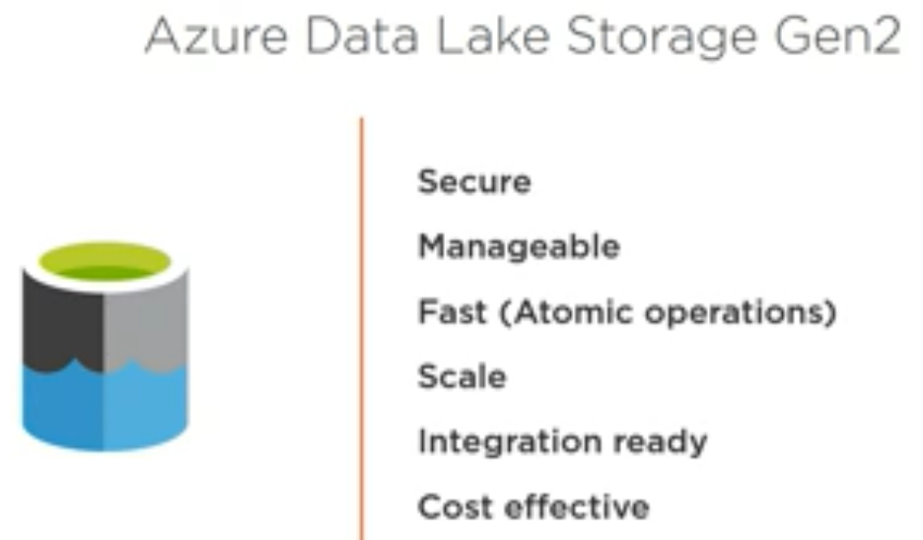

Additionally, Gen2 leverages blob's storage Azure Active Directory integration and role-based access controls, which is great, but it also extends even beyond these capabilities with the aid of a hierarchical namespace to enable fine grained, POSIX-based ACL support on files and folders.

And talking about files and folders, Gen2 is really manageable, delete is easy, rename is easy, and move is easy. You can organize and manipulate files through directories and subdirectories.

And performance, it is fast. You get atomic file operations with an enormous amount of throughput.

Let me put some context around this. Imagine you had a folder with 5000 files in a traditional object store. Let's say you need to rename this folder, if you had to perform such an operation on other object stores, it would mean that we have to do 5000 file copies and 5000 deletes, all because you have to perform these operations from the front end, but with Gen2 these operations take place in the back end, and so you need a single call. Can it get better than this?

And don't even get me started on the scalable part. There are no limits on data store size, and you get global footprint. It's available in all regions.

And obviously, it is integration ready, optimized for Spark and Hadoop, tightly integrated with the Hadoop vendors, which include Cloudera, DataBricks, and HortonWorks.

And of course, now the part that's music to your ears, it's cost effective, much lower cost, almost like blob storage, almost half the price of Gen1.

And all this is good, really good, but maybe you're wondering, what's the deal with the 2? I am talking about the virtues of Gen2, but haven't mentioned much of Gen1. And yes, you may already know everything about Gen1, but just in case, let me tell you. A few years ago, even before the times of the cloud, there was a technology that changed the world, Hadoop, which one of the key components was the Hadoop Distributed File System, which was widely sued as a data lake. On a historical note, it is worth mentioning that one of the reasons of why this technology was created was to help with the indexing of the entire internet, which is quite impressive. Anyway, end of historical note. And this technology, what we know as HDFS, is a fault tolerance file system where data was stored in large blocks and replicated, usually three times. One of its key advantages being that it was able to run on commodity hardware, no need for super expensive machines. And plenty of big data platforms used HDFS, starting with MapReduce, then Pig, Hive, Solr, Spark, and more. Wherever there was a big data platform, it was highly likely that HDFS might be around. And so it's no surprise that if we fast forward a few years, as companies move towards the cloud, Microsoft Azure, that we find “HDFS in the cloud”, and that service is what we know as Data Lake Store Gen1.

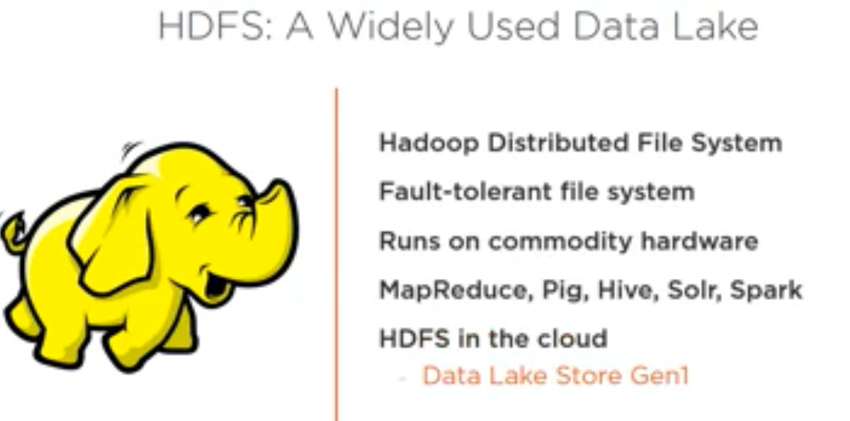

But the question remains, why did we end up with Gen2? Well, the answer is quite simple. As companies started to move to the cloud, they required multiple different services, for example, they needed processing power, but that was, at least in my very humble opinion, kind of straightforward to sort out. Create a virtual machine with an equivalent amount of vCPUs and all the RAM you need. You could optimize for processing or for memory or find the balance. But a VM is a VM after all. But with storage, it is a tad different. Requirements can vary substantially from application to application. You can have an application that streams audio or video or another application that performs transactions over structured data, or one that serves many small files, while another application may require huge files. Thus the storage story is a big broader. But there is one cloud object store in particular that has proven to be extremely useful, Azure Blob Storage, which is a large object storage in the cloud in all regions that is optimized for storing massive amounts of unstructured data, be it text or binary data. One key characteristic being that it is general purpose, you can use it for many things. Actually, if you're really interested in blob storage, please check the many courses in the library, like Configuring and Using Microsoft Azure Blob Storage, as well as docs. microsoft. com. Anyway, as mentioned, it is really cost efficient and you have multiple tiers, the more you use, the less you pay per gigabyte. Plus, depending on how frequently you use your data, you can store as hot, cool, or even archive with significant savings if you do not require data frequently. And so, given the wide spread option of HDFS and all of the advantages of blob storage, why not take advantage of both? And that's how we ended up with Gen2.

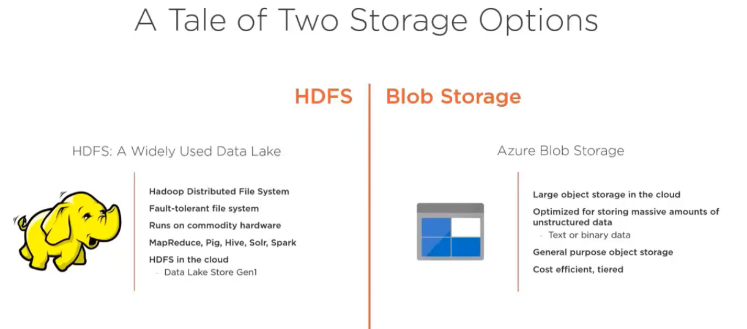

Architecture and Features of ADLS Gen2

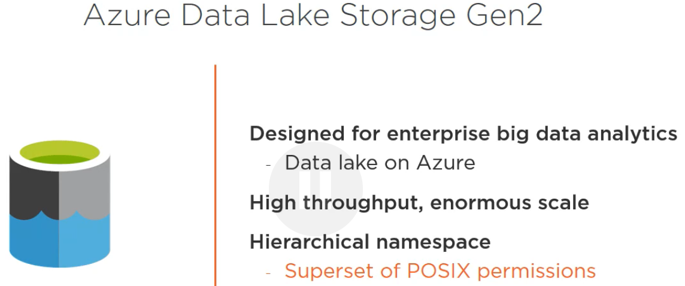

Let's take a couple of minutes to talk about a few important details about Azure Data Lake Store Gen2.

Gen2 has been designed for enterprise big data analytics. It is the foundational storage service for building enterprise data lakes on Microsoft Azure.   
  
It's capabilities includes having a very high throughput at an enormous scale.

It provides an easy way to manage massive amounts of data while giving you a hierarchical namespace, which means you get a superset of POSIX permissions. The security model for Data Lake Gen2 fully supports ACLs and POSIX permissions, along with some extra granularity specific to Data Lake Storage Gen2. Settings may be configured through admin tools or through frameworks, like Hive and Spark.

And it provides Hadoop compatible access, you can manage and access data just as you would with a Hadoop Distributed File System, or HDFS.   
The new Azure Blob File System driver, ABFS, is available within all Apache Hadoop environments to access data stored in Data Lake Storage Gen2, while still being blob compatible. Just a note, Gen2 is still under development, so some new features are being added from time to time.

Also, it's cost effective. Data Lake Storage Gen2 features low cost storage capacity and transactions, as data transitions through its complete lifecycle, building rates change, keeping costs to a minimum via built-in features, such as Azure Blob Storage Lifecycle.

And we're close to creating our data lake, but before, let me just mention a couple of things on the hierarchical namespace, as this is a key differentiator. You can enable it or disable it. It's up to you. But there are a few points to consider.   
If you enable it, you get atomic directory manipulation and a familiar file system, which is well known by developers, recommended for any application that requires directories or datasets that require being organized. If you want to know, one of the reasons why historically object storage does not support a directory structure was because of scalability. However, Gen2 scale is nearly linearly, thus no limitation there.   
On the other hand, you may want to disable the hierarchical namespace, as there are some workloads that may not benefit, like images or backups, or other workloads that store the organization data separately. It all depends on your requirements.

Another quick note, at the time of this course creation, if you enable the hierarchical namespace, there is no interoperability of data or operations between blob and Data Lake Storage Gen2 REST APIs. This functionality is going to be added soon.   
  
So in summary, you get blob storage, which gives you object tiering, lifecycle policy management, Azure Active Directory integration, role-based access controls, storage account security, high availability, disaster recovery, data governance and management. But additionally, with Gen2, you get performance enhancements, security, scale, and cost effectiveness, and best of all, you can access via the blob API or the ADLs API. Good, now that we talked about all that, it is time to create our Azure Data Lake Store Gen2.

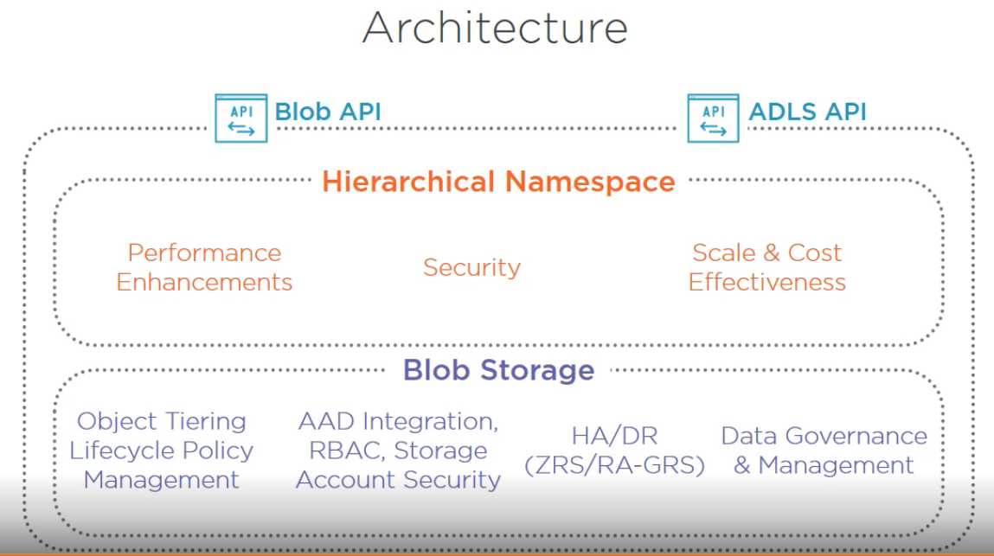

Demo: Creating an Azure Data Lake Store Gen2 with Portal

Just as the old saying goes, all roads lead to Rome. In the same way, when working with Microsoft Azure, there are many ways of creating services. For example, if you navigate to the Azure Storage Documentation, you can clearly see some of the quickstarts that explain how to work with Azure Storage. They are clearly labeled so that you can pick your favorite one. For example, you might want to work with Portal, then here it is, or PowerShell, or the CLI. Not bad, right? Okay, good. So now let me show you a demo on creating an Azure Data Lake Store Gen2 using Portal. If you're watching this course, I am assuming that you have already mastered some of the steps that I'm going to take, as they are pretty general, but still, for this demo, I would like to take it from the top. That is, start at the resource group level. That way I also do not have to make any assumptions on what you have or have not created in Azure. Good, so let's go and click on Resource groups, alternatively you can click on Crate a resource, and now in the resource groups page, let's click on Add. At this moment, there is nothing that's Data Lake Store Gen2 specific. We're just going to provide the resource group name, which in my case is going to be datalake-ps. I will use my subscription, and for location, as you are aware, there are many that you can use. In my case, I will pick West US 2. Please remember this selection as you will need it later on. Now, I'll click on Create, and validating takes place. Wait a few seconds and the resource group has been created. Now let's click on Go to resource group, and here we are. Datalake-ps has been created. And now let's go to Storage accounts. Here is where we will create our Data Lake Store Gen2. There's nothing out of the ordinary. Let's just click on Add and follow the steps to create a storage account, beginning with the basic step.

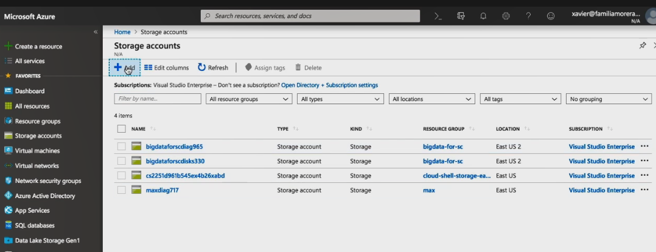

Here I'll be selecting the resource group that I just created, datalake-ps. Now, let me pause here for a second to show you something.

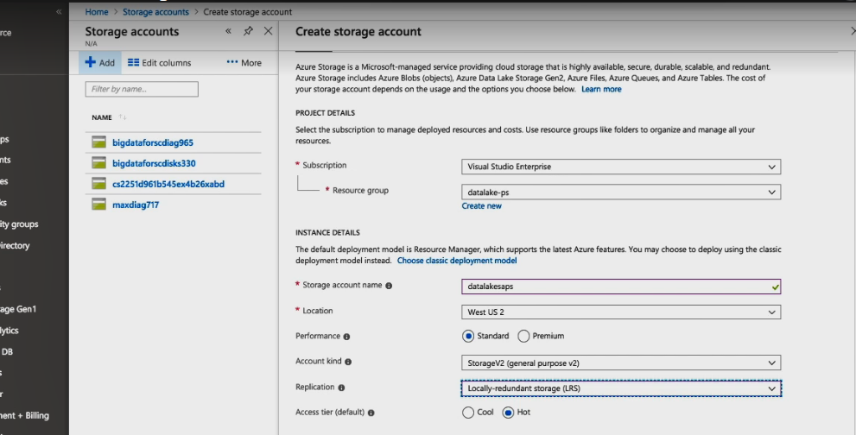

Storage account names need to be unique, and datalake is taken, obviously. So I will create a unique one, and there you go, this works well. Now I will pick location. Let's use the same one where we created a resource group. In my case, it is West US 2. Now, let's go on to the next setting. Here we're going to pick the account kind. There are several options. Let's use StorageV2.   
Now another important point is replication, which is used to ensure durability and availability. This setting specifies how many copies and where you want of your data, namely replicate in the same data center within data centers in the same region or even across regions. It's great for planned and unplanned events, ranging from hardware failures, network or power outages, natural disasters, and more. I will specify locally-redundant, LRS, which is good for what I want to show you now.

And then the access tier, hot is for data that's accessed frequently and cool for infrequently accessed data. This looks good, so let's click on Next. And we are in the Advanced tab.

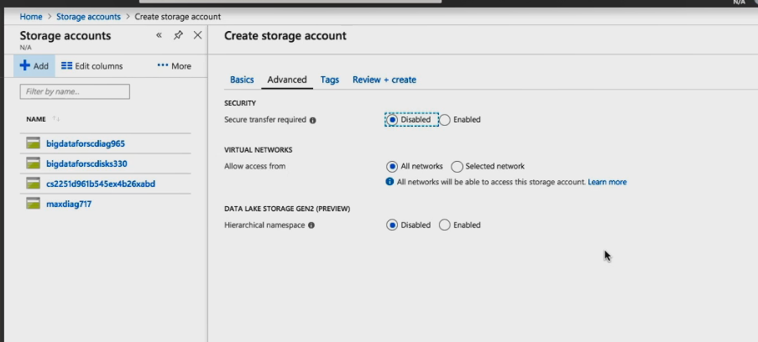

Let's disable secure transfer required. For virtual networks, I will leave access from all networks, but change this per your requirements. And now, this is important, you can specify if you want a hierarchical namespace. You can also disable it, if that's what you want, but in my case I will enable it. Now let's click on Next. And I am in the Tags. Tags are helpful when you have many resources. They let you identify them easily, but I won't add any at this point. Now, click on Next and Azure performs a validation.

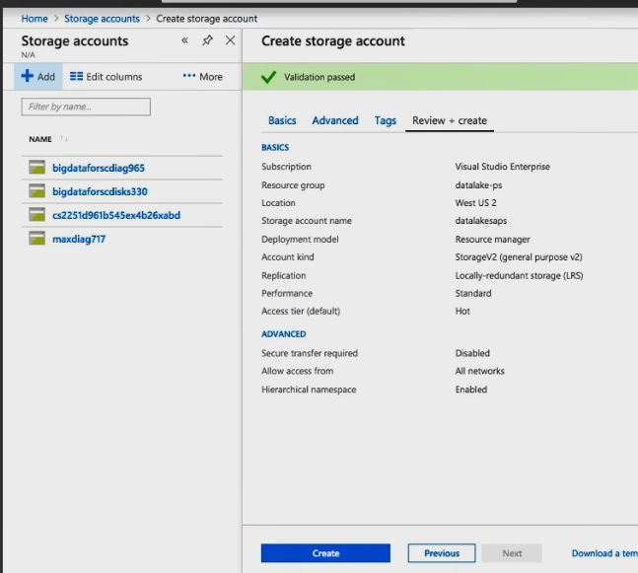

After a few seconds, validations passes and we're good. We are one step away from creating our data lake. At this point, I just want to remind you that you can download a template for automating this process, but that's the subject of another training.

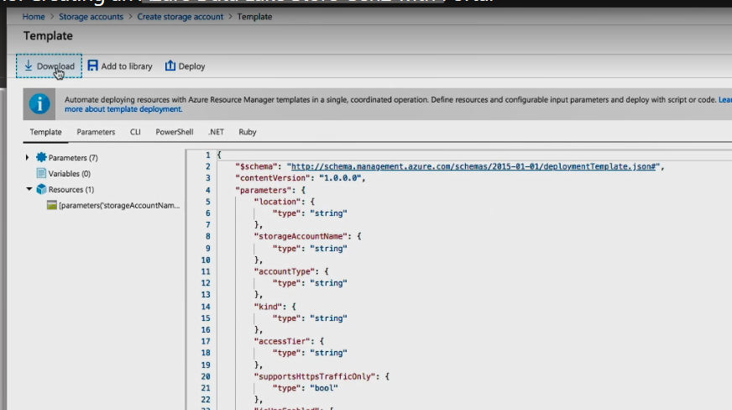

So I'll click on Create and deployment starts. As you can see, it has been submitted. A few seconds and it is in progress. There is actually a nice duration counter right here.

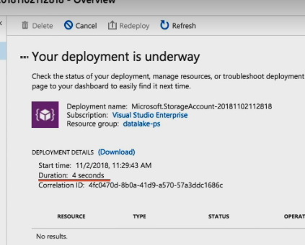

You can see it as it goes up. I can check the operation details, the status is accepted, provisioning state is running. And finally, after a few seconds, deployment succeeded.

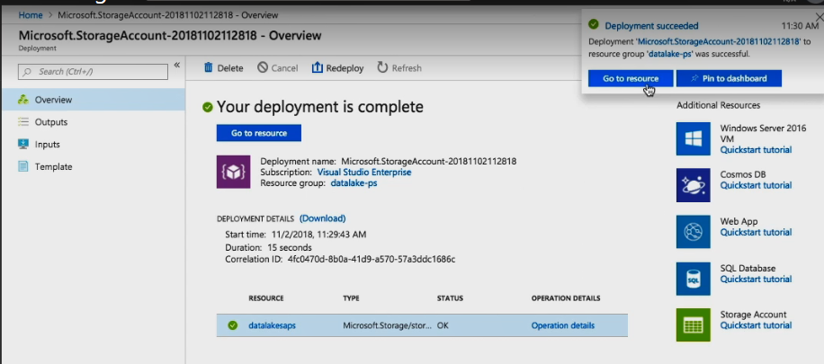

At this point, I'm going to click on Go to resource, and congratulations, now that you have created a storage account, you have a Data Lake Store Gen2. It is empty though, so in the upcoming module, we will start ingesting data into our data lake. But before, I have something else that I would like to show you.

Demo: Creating and Deleting an Azure Data Lake Store Gen 2 with PowerShell

In the previous demo, I created a storage account, enabling hierarchical namespace on my Data Lake Gen2. And it all went really well. But in case you prefer not to use Portal, I will show you another way, using Powershell. Let me start by opening my Cloud Shell. It'll take a few seconds to initialize, but in the meantime, I'm going to maximize it. Good. This looks fine. Now I'll start by declaring a couple of variables. First, I'll have $resourceGroup, which will be datalake-sg-ps. Here I typed sg to denote second group. Of course, this is going to be the name of our resource group. And then the other variable, $location, which equals westus2. If you're wondering, where did I get this value from because you don't explicitly remember the locations, just wait, I'll show you in a few minutes. And now, it's New-AzureRmResourceGroup, then minus Name, the variable we just declared, $resourceGroup, minus location, the other variable, $location. And now hit Enter, and as easy as that I have created the new resource group.

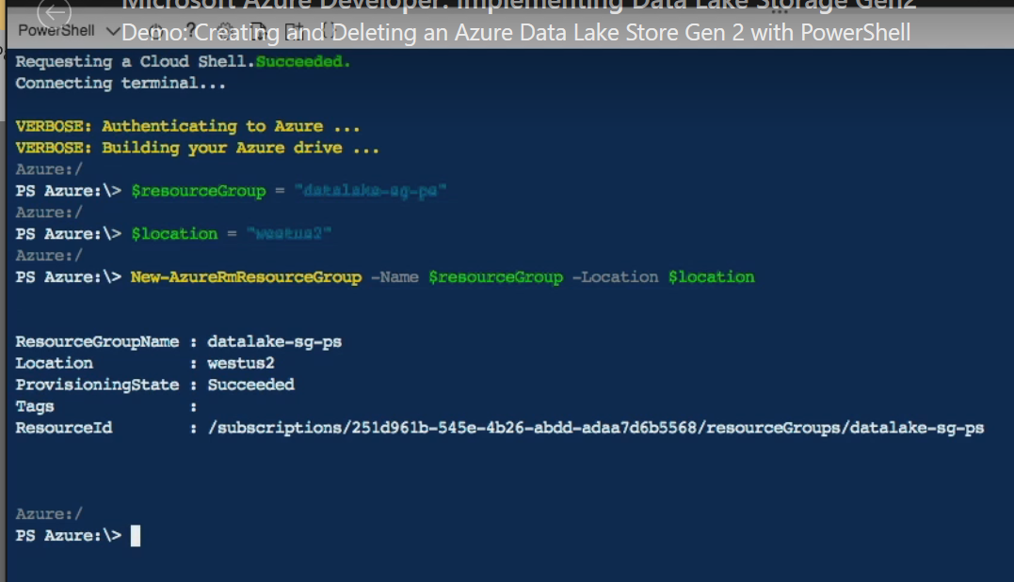

Now I will clear, and before moving forward I'll show you where you can get your locations in an easy way. I'll just use Get-AzureRmLocation | select Location. And there they are.

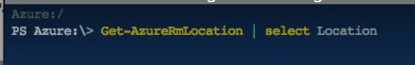

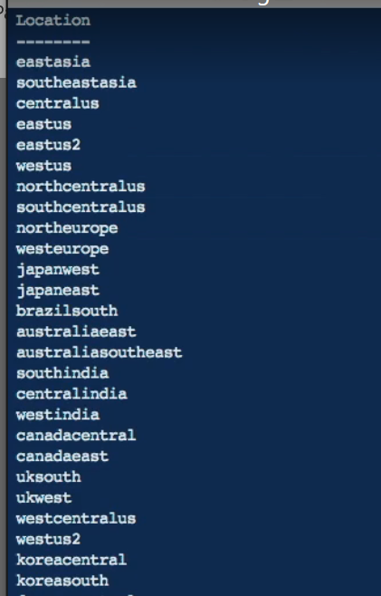

They are pretty understandable. Mine is right here, westus2. Anyway, let's continue. And this is the command, New-AzureRmStorageAccount, then -ResourceGroupName, and I'll use the same variable, $resourceGroup, minus Name, and I'll put the name datalakeps, then minus Location, it's still $location, minus SkuName Standard_LRS. This is the locally redundant storage. Then minus Kind, and it's going to be StorageV2. I'll hit Enter, I'll wait a little bit, and my StorageAccountName is ready.

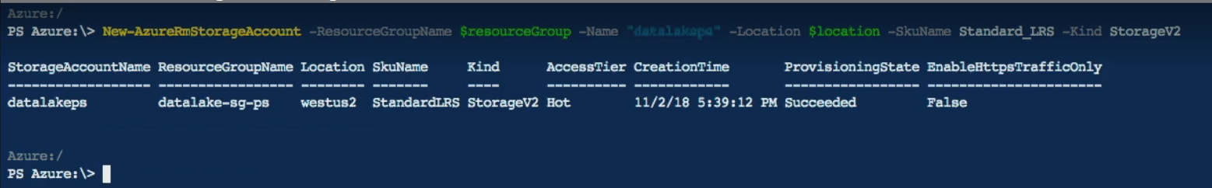

And to confirm, I will go to Storage accounts. And I can see both storage accounts there, the one I created via Portal and the one I created using PowerShell. Okay, good. Now just one more thing before we move forward.

Let me open another Cloud Shell. Maximize it, and now I'll remove the resource group to delete my data lake. The command is simple, Remove-AzureRmResourceGroup, minus Name, and the name of the resource group I just created. But remember, this is very important, if you delete your resource group, you delete everything that's part of the resource group. So please be very careful. Okay, this also takes some time, so I'll speed this up a little bit until I can see the return value True. And now if I navigate into my resource group, I can see that it is gone.   
Great. Now you know how to create data lakes, so the next step is to ingest some data, which is what we will cover in the next module, but first, the takeaway.

Takeaway

In summary, data is key, the more the better. And data is something that historically has been stored in data lakes, one of the most important ones being HDFS, or the Hadoop Distributed File System.   
But as data and applications move to the cloud, other types of data lakes were used, like Blob Storage, which has many key advantages as well. But why not leverage all the things that are good from HDFS plus the good things from Blob Storage? Well, that is what we know as Azure Data Lake Store Gen2.

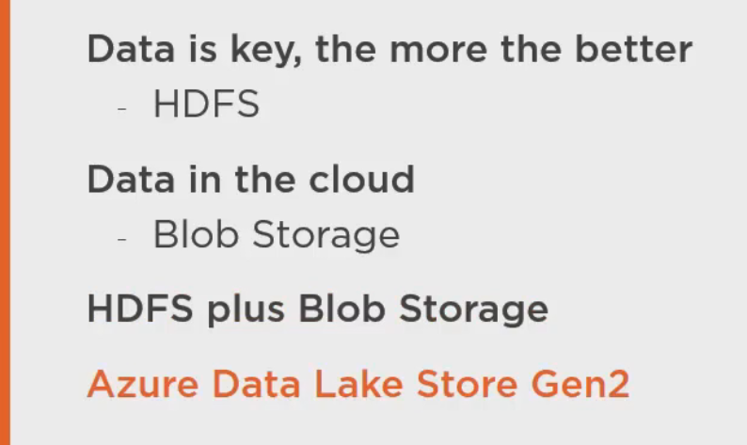

And just to name these benefits, they include a hierarchical namespace at massive scale with great performance at a low cost and integrated with the major Hadoop vendors. And best of all, I showed you how easy it is to create a Data Lake Store Gen2. And now, it is time to move on into the next module to start ingesting data into our data lake.

Managing Data with Azure Data Lake Store Gen2

Managing data with Azure Data Lake Store Gen2. In the previous module, we learned of two ways of how to create a data lake using Portal and PowerShell. And now that we have our Data Lake Store Gen2 ready, let's talk about some other really important topics, ingesting data, managing data, and securing data.

Let's Talk About Ingesting Data and Securing It

Earlier, we covered why data, and big data in particular, is so important. Remember, if you don't have data, you're just another person with an opinion. Data driven insights give you a competitive edge and so now that we have a data lake, the big question is, how do we get data into our data lake? Well, needless to say there are many ways to ingest data, some that are supported right now, while a few more that are either in preview or in the Microsoft Azure roadmap. But before I show you how to ingest data, let me spend a couple of minutes talking about another important and related topic, securing your data. Security is really important and even though Microsoft Azure is already very secure, that does not mean that you can just ignore security, because if you do, you might end up in the news for the wrong reasons. Anyhow, lucky for us, Microsoft Azure provides many ways of security your data when using Data Lake Storage Gen2, which include a superset of POSIX permissions. The security model supports ACL and POSIX permissions along with some extra granularity specific to Data Lake Storage Gen2. Settings may be configured through admin tools or through frameworks, like Hive and Spark.

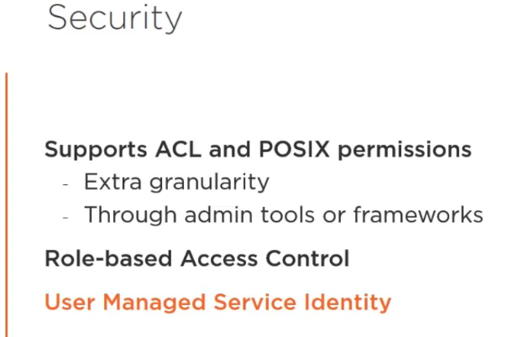Support for RBAC: And additionally, Data Lake Store Gen2 supports role-based access control, also known as RBAC. And you can secure your data with User Managed Service Identity, or MSI, which is a way of granting permission to a “resource to use another resource.” For example, we can grant access to nodes within an HDI cluster to access our data lake, we just assign these nodes a specific role, which is something that I'll demonstrate in the upcoming demos. But now let's go to the fun part, let's learn how to ingest data into an Azure Data Lake Store Gen2.

And for this, I'll show you three different ways.   
  
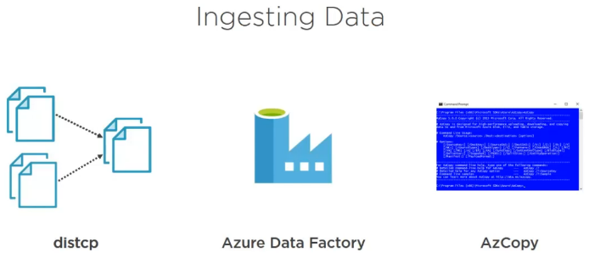First with distcp, which is a tool that will be very familiar for those that have experience with HDFS. Distcp stands for distributed copy and it is a tool used for larger inter and intra-cluster copying. It uses a MapReduce job and it expands a list of files and directories into input to map tasks, each of which will copy a partition of the files specified in the source list.

Then Azure Data Factory, which is a service that integrates disparate data sources and lets you create pipelines to move data.

And finally, we will use AzCopy, or Azure Storage Copy, which is a command line utility that's used for copying data to and from Microsoft Azure Blob and File Storage. And we can use it also for Gen2, of course. “Remember that ADLS Gen2 is Blob Storage.”

Also, we will use Hadoop commands, which thanks to the ABFS driver, there is nothing new for you to learn. The only thing that changes is a slight variation in the URI scheme, but aside from that, it all works wonderfully. And we will also learn how to interact with our data lake using the REST API, which if you think about it, the REST API is really important, as by leveraging the REST API, you can create applications that automate certain operations on your data lake. Having said that, let's begin.

Ingesting Data to ADLS Gen2 from AWS S3 Using Azure Data Factory

Demo, Ingesting Data into ADLS Gen2 from AWS S3 using Azure Data Factory. Yes that's right, from AWS S3. Let's imagine that you have a bunch of data in another teleprovider and you're tasked to move this data to Microsoft Azure. Well, how hard of a task is this? It turns out it's quite easy. Check this out. From the dashboard, let's select Create a resource, Analytics, Data Factory. Now let's fill in the required fields, starting with the name. I'll use adfmovetogen2. Then, I'll leave my subscription as is and I'll select the resource group that I created earlier, where I have my data lake, datalake-ps. V2 is fine and then, this is important, I will select the same location as where I created my data lake, West US 2. Now let's click on Create and a quick validation takes place.

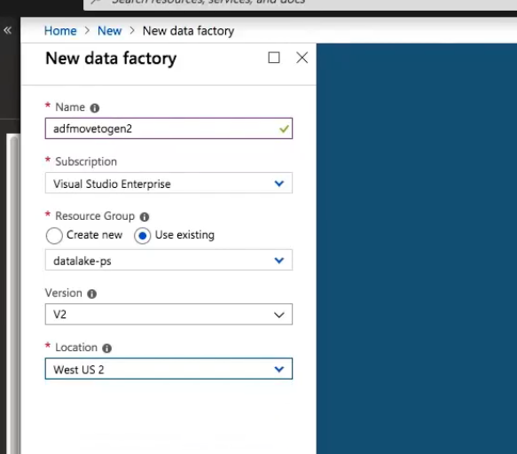

The deployment is submitted and shortly the deployment will be complete. Let's click on Go to resource. And here it is, our Azure Data Factory, ADF, moved to Gen2.

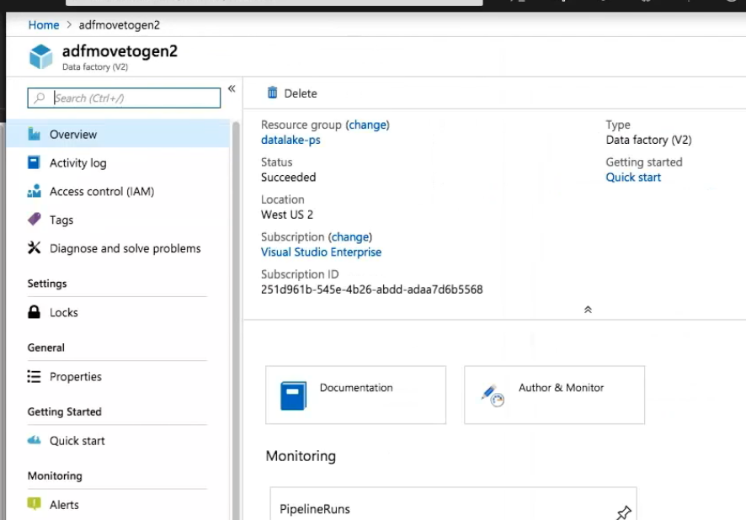

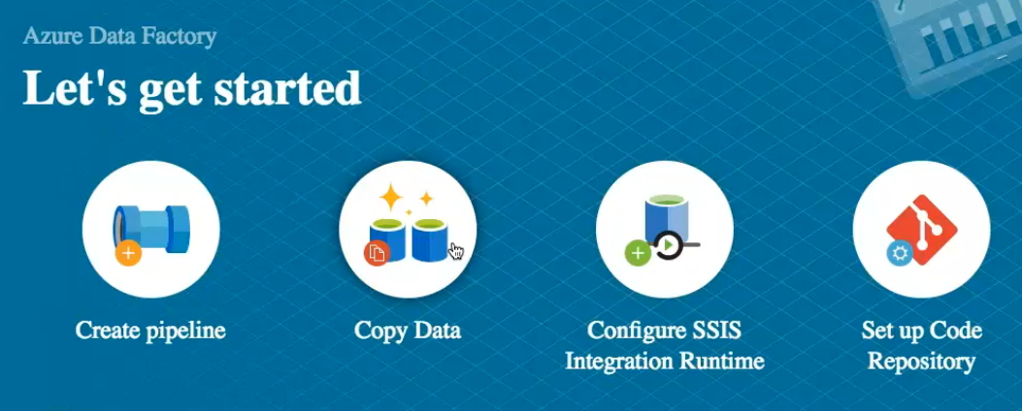

There are several options now, but I will select Copy Data. Here I will create a task and the name will be copyfroms3. The description is not required, but by all means add one if you have many tasks. And now I will only run this once, although you can schedule the task. Let's click on Next. Now let's specify the source data store as we have none. The reason is that this is a new task with a new data factory, but if you create a source data store, you can now reuse it among your tasks. Let's click on Create new connection and here you can filter by using Search or simply finding the one that you need. I'll pick S3 and click on Continue. First, let's give the linked service a name. I will use AmazonS3data. Description, again, is optional, but security is not. Here I will provide the Access Key ID and then the Secret Access Key. Optionally, you might use Azure Key Vault, but for now, I'll stick to the Secret Access Key. I test the connection, and all looks good. So I click on Finish. A few moments later, I can see a notification telling me my source has been saved and I can see it right here. It is selected. So let's click Next. Time to specify which folder I am going to copy. I'll click on stackexchangex, then vi. stackexchange, and those are the files that I want to copy. So just to confirm, I'll open the stackexchangex bucket, vi. stackexchange folder, and yes, those are the same files I am looking at from ADF. So now I can click on Choose. I will check both copy file recursively and binary copy. Those two are important to make an exact copy.

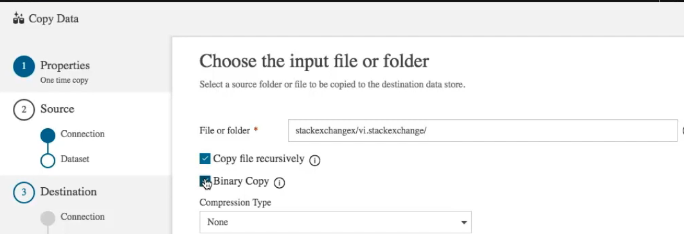

At this point, I am not going to use compression, so I will click on Next. Time for the destination data store. So let's click on Create new connection, and we specified the New Linked Service. As we can see, we have Blob Storage, Data Lake Gen1, and Gen2, File Storage, and File System. Please select Gen2. Now I will provide the name. I'll use AzureDataLakeStorageGen2. The account selection method from Azure subscription. The Azure subscription, which at this point I only have one, and now this is important, the Storage account name. I will use the one that I created recently, datalakesaps. And when I click on Finish, the link service will be published immediately. So first, I need to test connection, and all looks good, which means I can now click and finish. So it's ready and selected. So let's click on Next. Now we're going to specify the output file or folder. So let's click Browse, there you go, and I can see that there are two file systems here. I will select datalakegen2hdifs, which is a container within my storage account. If I select it, I can see many more folders. This file system in particular was created when I deployed an HDInsight cluster, that's why there are several files and folders already there. I did it on purpose to make more evident the hierarchical nature of the data lake, but don't worry, in the upcoming module I will show you how to deploy a cluster. Feel free to use an empty container for now. Let's click on Choose, and let's append the name of the new folder, datafroms3.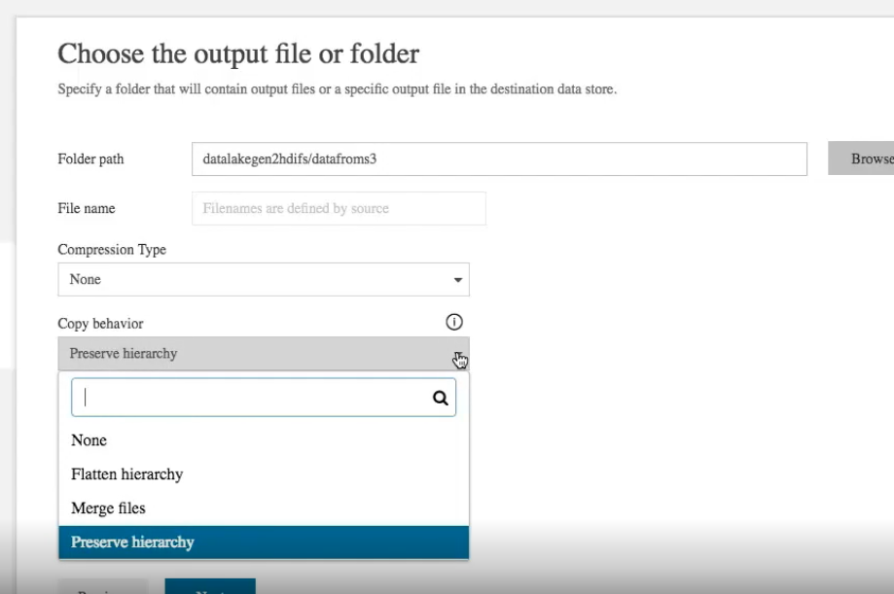

Again, no compression, and the copy behavior is quite important, you can flatten hierarchy, merge files, and preserve hierarchy. That's the one that I'm interested in, preserve hierarchy. So let's click on Next. In this Settings page, in advance, you can specify the degree of copy parallelism.

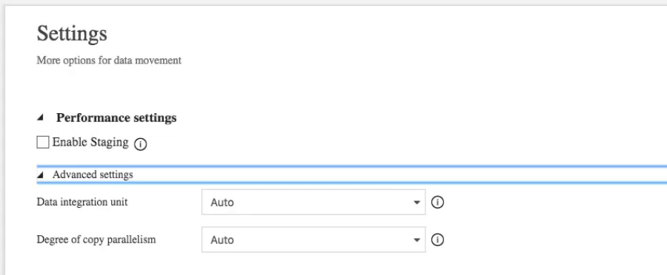

Depending on the size of your data, this can be useful. But it might also consume more resources. So I will not use it. Time to click on Next. And finally, we get to the Summary page. Let's review. From S3 to Gen2, all settings look good. Let me scroll down a little bit, and now I'll click Next, and the deployment starts. Now I can click on Monitor to see the pipeline run in progress. The amount of time it takes depends on the size of your data. Mine is reasonably sized, so I click on Refresh and it has succeeded. Now I am going to open a terminal in a node from HDInsight cluster that I'm currently running. From here, I'll run my commands as this cluster is configured to use the container I selected as destination data store as its default file system. And don't worry for now, I'm just going to run a command to list the files to confirm that this worked. And this is a pure HDFS command. So it's hdfs dfs -ls /. And I can see the folder where I specified that I wanted to copy my files, datafroms3. Now, I will check inside that folder, and I can see all my XML files.

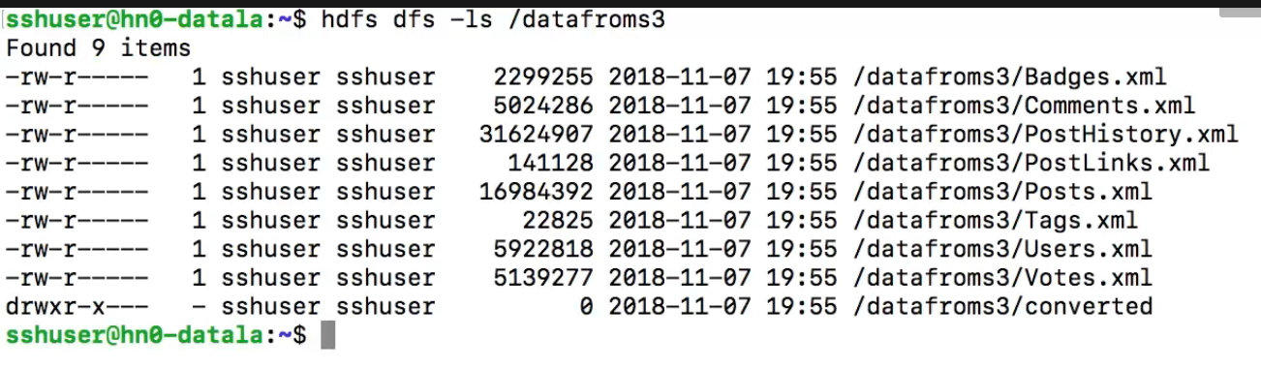

And I can even go one level deeper into a subfolder called converted. And, as mentioned, I moved a small amount of data for this demo, but ADF can handle large loads.

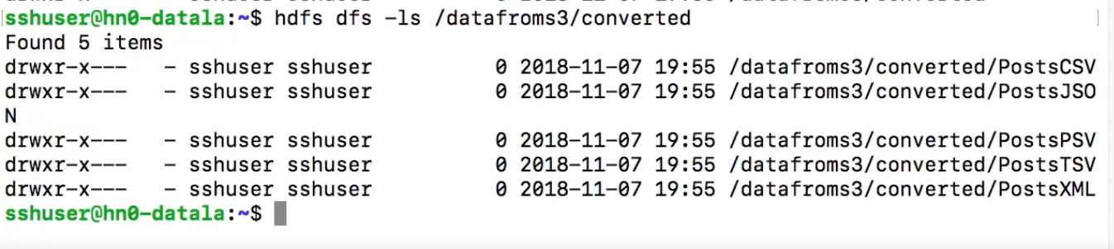

summary, that worked quite well. We have moved our data from another cloud provider to Microsoft Azure.

Ingesting Data to ADLS Gen2 from ADLS Gen1 Using ADF

In the previous demo we ingested data that was stored in another cloud provider, but it may be the case that you already have your data in Microsoft Azure, in a data lake, and possibly Azure Data Lake Store Gen1. But now you want to benefit from all the advantages of Gen2. So this demo is for you. Copying data from ADLS Gen1 to Gen2 with Azure Data Factory. And I start by reusing the same data factory that I created in the previous clip, adfmovetogen2. Although if you want to create a new one, that's okay as well. I can see here at the top right the two data sources that I created earlier. Let's create a task by clicking on Copy Data. I'm going to be providing a name, which in this case it's going to be movefromgen1, and it is pretty self explanatory. I'll leave the description as is, remember that it's optional. And again, I'm only going to be running it once. So I'll also leave this as is. Now I'll click on Next. Time to create our source data store, and given that we're reusing this data factory, we already have two connections. So let's create a new one for my Azure Data Lake Store Gen1. Let's click on Create new connection, and filter by Azure sources. There's the one that I'm looking for, Gen1, so I'll select it and click on Continue. I'll give it a name. I'm going to leave description empty and I'll leave Connect via integration runtime. Okay. Data Lake Store selection method, that will be from Azure subscription. And now I'm going to select my data lake. The Data Lake Gen1 where I have all my data is called datalakegen1source. I am assuming that you already have a Data Lake Gen1. If not, creating one and uploading data is easy. Okay that is my tenant ID and this next one is very important, how you're going to authenticate the security piece. There are several ways, but a recommended one is User Managed Service Identity, or MSI, which is a way in which you don't have to store user names and passwords. Instead, you grant access from one service to another.

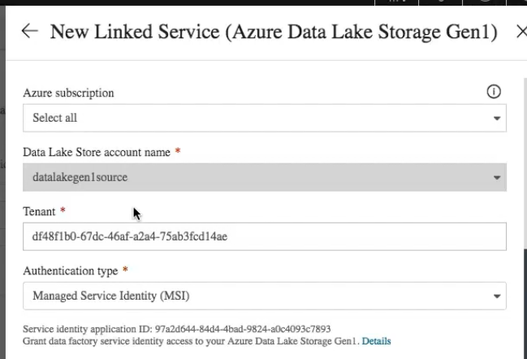

How? You will notice here my service identity application ID and this message, Grant data factory service identity access to your Azure Data Lake Storage Gen1. And there's a link. Okay that's what we need, now let me show you. I will open another window. And here I have my Data Lake Store Gen1. I want to see my data. So the easiest way is to click on Data explorer. Here is my main folder, data. Now I can browse and see more folders with more files. But how do I grant access? Let me go back to the root folder and I'll click on Access control, IAM, and as you can see here, I have added my Azure Data Factory, adfmovetogen2, as Owner. If you want to grant access to more resources, simply click on Add and include them here.

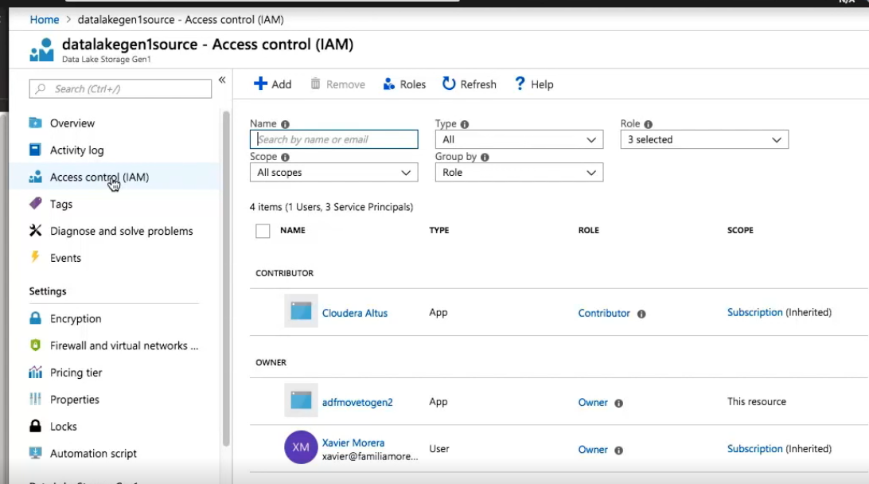

There are several different roles. You can also add as contributor. And that's it. Just by doing this, I have granted access for ADF to my Data Lake Store Gen1. Now let's go back and click on Test connection. This worked quite well. So we can click now on Finish and I will get a confirmation that my data source has been created. And of course, it's conveniently selected. It means we're ready, so let's click on Next.

At this point, we can click on Browse, and I can see a data folder right here. that means that our ADF is connecting and reading the contents of our Data Lake Store Gen1. I will select it and check Copy file recursively and Binary Copy, both of these are important to move our data exactly as it is right now. Click on Next. And since we already had the DataLakeStorageGen2 connection created, we will just select it and click Next. Which takes us to this screen, which is where we select the location where we want to copy our data. Let's click on Browse. And I have two right now that I created earlier. I will select datalakegen2hdifs, which is the file system that I created for the HDInsight cluster that I have running right now. At this point, I want to create a new folder. So I just select an existing one and modify the name to create it. I'll call it conveniently datafromgen1. Click on Next, and here in the Settings, I will leave the default values. Remember, here's where you can control parallelism. Let's click on Next and then the summary where we will review everything. Once you're ready, click on Next, and the deployment will start. At this point, we're creating the datasets, creating the pipelines, and running the pipelines. We have three green checkmarks, which means we're good, so let's click on Finish. So now let's go back to the terminal in my HDInsight cluster. Remember, this is a cluster that has, as default file system, the one where we selected to copy the contents of our Data Lake Store Gen1. The name was datalakegen2hdifs. So, the command is very simple, hdfs dfs -ls /, and we can see the data folder from our gen1 right here, which, if we check the contents, we can see all the subfolders that we had in this store. And that, ladies and gentlemen, is how you copy data from Azure Data Lake Store Gen1 to Azure Data Lake Store Gen2.

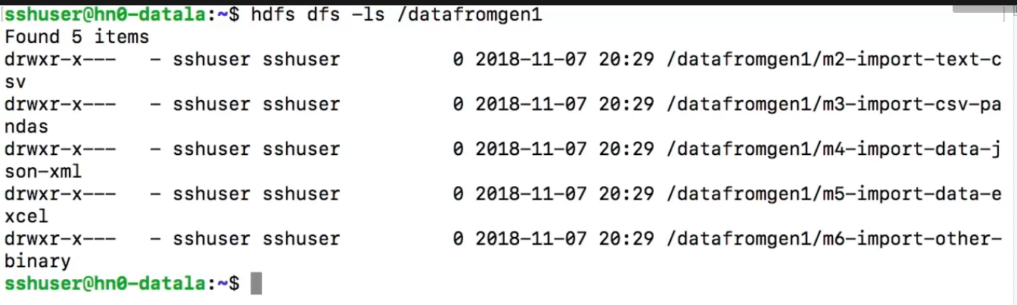

Need to check if we can use managed identity for Gen2. Here in example it showed that we can use managed identity with ADF Gen 1.

Using the Azure Data Lake Store REST API

And it's time for the next demo, using the Azure Data Lake Store Gen2 REST API. In the previous demos, we created a storage account from Portal. We copied data via Azure Data Factory and we listed our files using HDFS from an HDInsight cluster that I had available. All good, no issues, until now. However, it is also important to learn about a few other ways of interacting with your Azure Data Lake Store Gen2, like the REST API.

And I don't need to tell you again, but an API is extremely important because it is one of the best ways to build applications that integrate with your data lake. There are several things that you can do, for example, you can create or delete a filesystem, get or set properties, and list. And then you can create directories or rename them or delete them. You can get a lease or list. And of course, you can read and update your data.

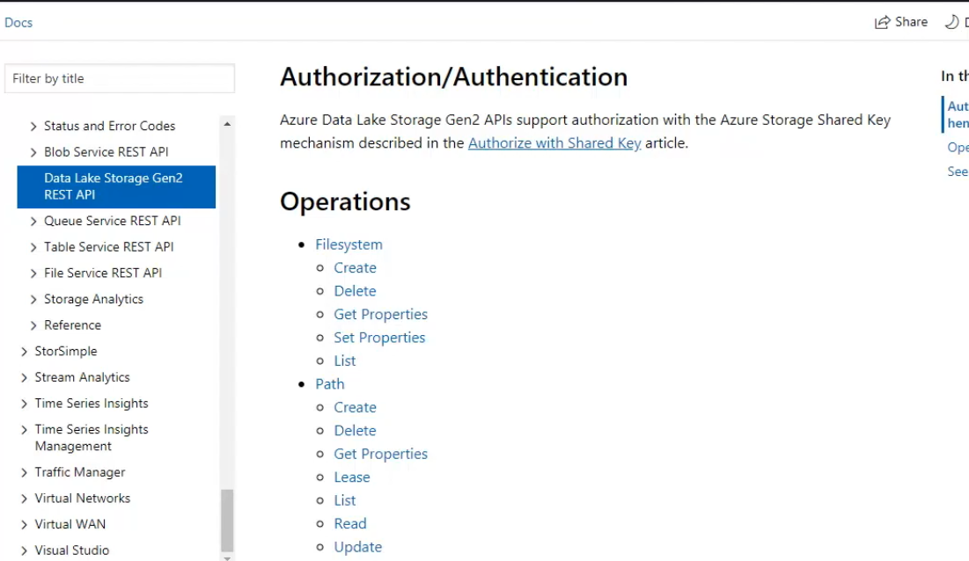

It's very useful. And how hard is it to work with the Azure Data Lake Store Gen2 REST API? Well, not that much. Let me show you. From the dashboard, let's search for App registrations. And there it is, so let's select it. And here we are, our application registrations. We have none at this point. So let's click on New application registration. Now it's time to create one. Provide a name, I'll use azurerestapi, and leave application type as Web app/API. We need to provide a sign-on URL, and localhost is fine. Now let's click the Create button and it'll just take a few moments,

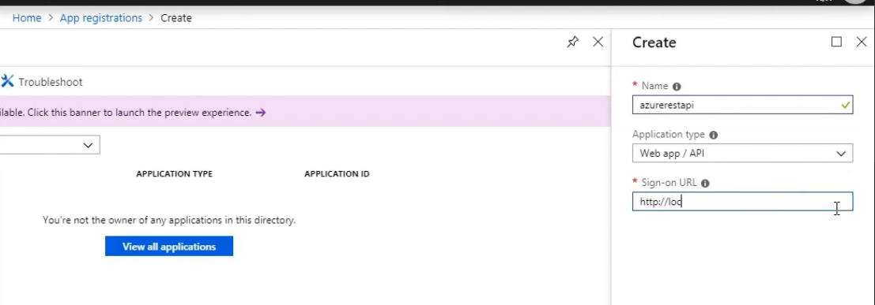

but now you get a notification telling you that you have successfully created the application as your REST API. We're going to need the application ID, so copy it and keep it in a safe place.

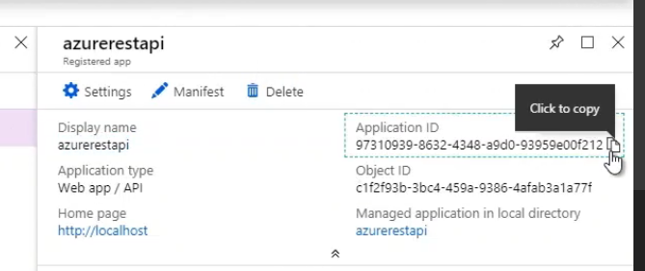

Next, click on Settings and a new blade opens. From here select Keys. Now let's create one. I'll use restdemo for Description and then on Expires, I'll set it to 1 year. Once you have, you will get the key value. Copy it, as you won't be able to retrieve it once you leave this blade.

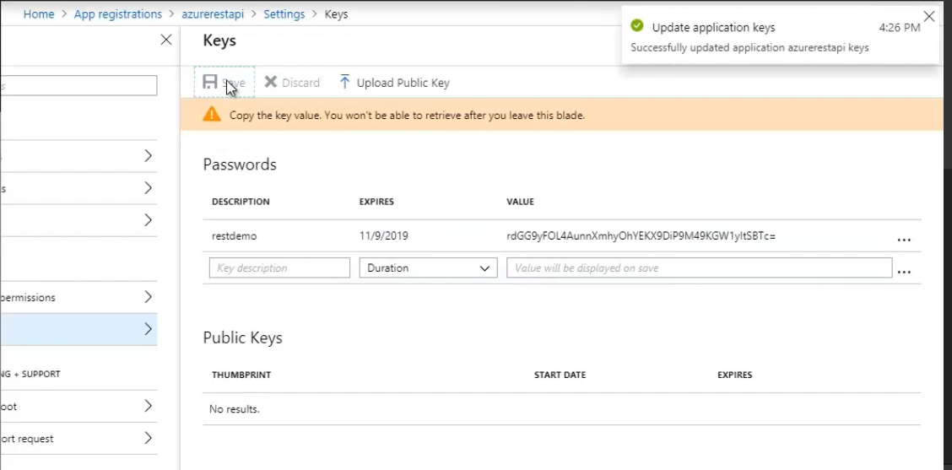

Done. By the way, it's worth mentioning that if you believe you have lost your key, you can delete it and create a new one. And also, you can upload a public key. Let's go back to Settings and from the Settings blade, click on Required permissions. And now, click on Add. At this point, we can provide the required permission for API access. For this, we're going to click on Select an API. And now you can directly select or use the search functionality. I'll use the search functionality and I'll look for Azure storage. And there it is. Now select it and click the Select button. Now we need to enable access. The first thing I check is that it is set as requires admin access, and no, which is good. So I'm going to tick the checkbox, click on Select, wait a second or two, and click on Done. At this point, I'm going to get a notification telling me that permissions are being added, but immediately I get a green checkmark, which tells us that we have successfully added the application Azure Storage's permission.

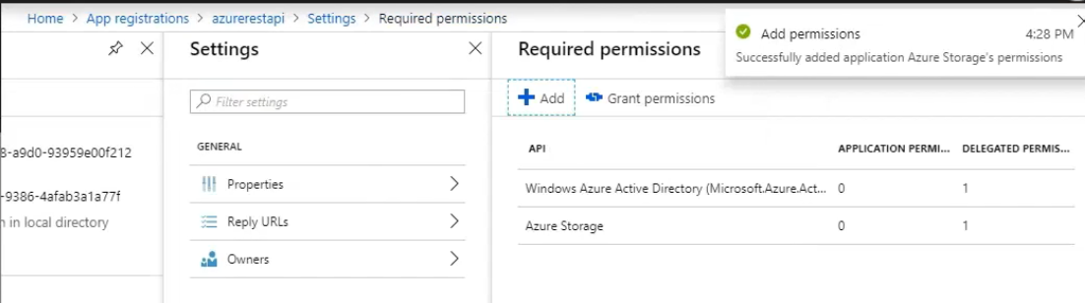

Let's close and go to Storage accounts. Here, let's select the storage account that we created earlier, datalakesaps. Now we're going to click on Access control, IAM, and let's add permissions. At this point, it's better if we use the search functionality to look for Storage Blob Data Contributor. And there it is. So I select it. I will leave assign access to Azure AD user, group, or application, and I will look for my application. This is the one that I just created, azurerestapi.

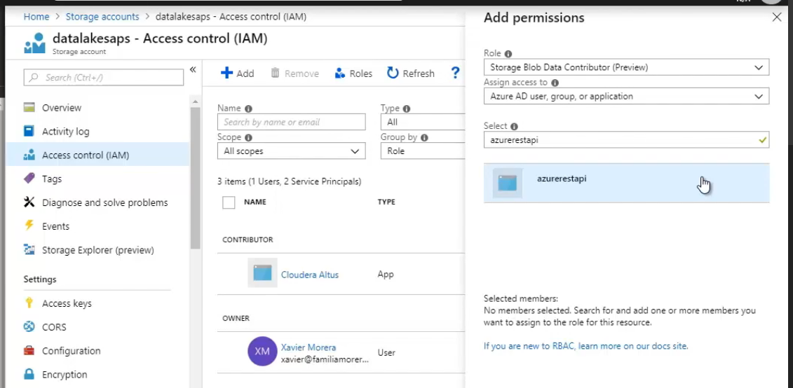

It is better if you use the search functionality, as it will most likely not show up in the list. Okay, now that found it, we just select it and click Save. At this point, we get a notification of adding role assignment. We wait a few seconds and now it is ready. At this point, we have created and configured what we need to call the REST API. However, there are a few more pieces of information that are required. One that you may already have, as it's likely that you have used it before, is the tenant ID, which you can get from the Azure Active Directory, and it is listed as Directory ID. Copy it as you will need it soon.

Now let's go back to the data lake storage account. We're going to copy the access key and store it safely. Remember to rotate your keys and not share them with anybody. Once you have the tenant ID and the access key, we can now make our calls to the REST API. There are many ways to call an API, and in my case I will use curl and from the Cloud Shell. This will make it easier to explain. So let's open the Cloud Shell, let's wait for a few moments for it to initialize, and in the meantime I will enlarge the font and clear. Okay, now we're ready.

First step is to get an OAuth2 access token, which we will use on every call for authorization. There are three values that we need to provide, the CLIENT_ID, which is the service principle ID, the account CLIENT_SECRET, and the TENANT_NAME, which we just found as directory_id. And the value that it returns, it's a bearer token.

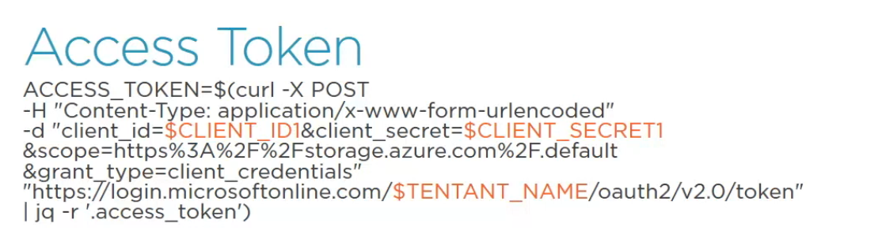

And this would be the command that we use. We just need to replace the values in orange. Oh, and by the way, this is included in the exercise files. So let me show you. And now I will make a call to Path - List. And this the call that we need to make.

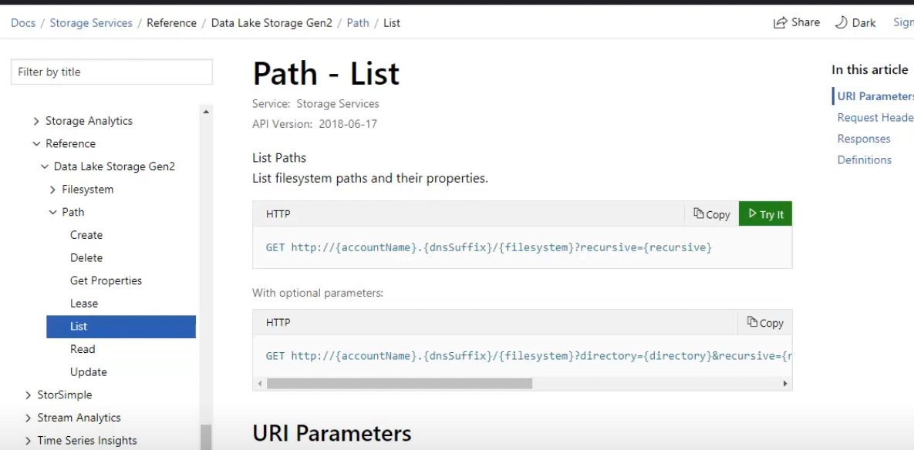

In a minute I will show you the actual one with curl, but first I want to mention a few of the URI parameters so that you can identify them later. As we can see here, we need to provide the accountName, dsnSuffix, /filesystem and recursive, which can be true or false. So now if we open the Cloud Shell, we can see curl, the authorization bearer, OAuth2 token, which is all this text, and the actual call, which has the account name, datalakesaps, the dnsSuffix, dfs. core. windows. net, then the filesystem, which is datalakegen2hdifs, then resource=filesystem and recursive false.

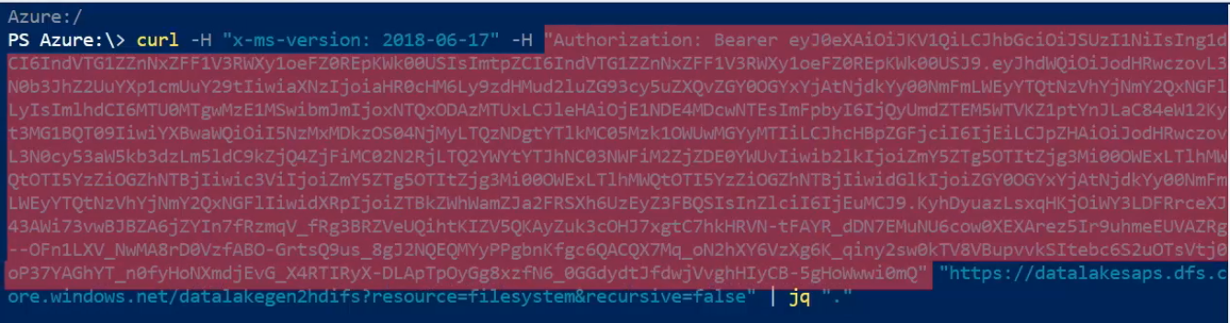

We're only going to get the folders and files in the root of this filesystem. Once we make the call, we get a

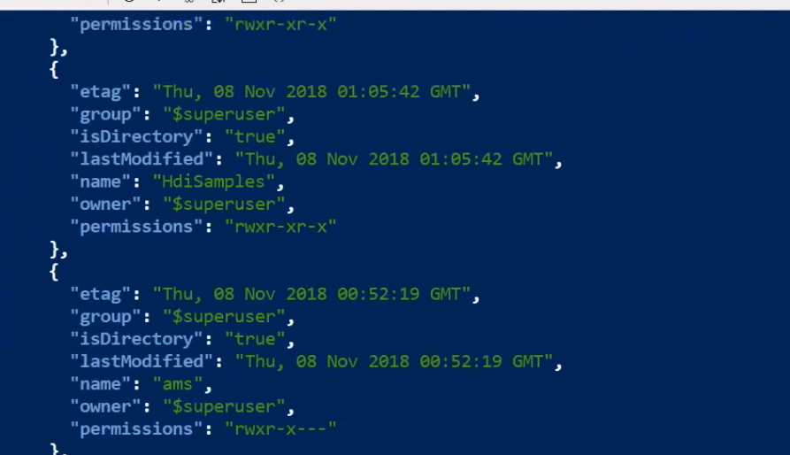

response, which has all the paths that we've seen earlier using hdfs dfs -ls. And that's how easy it is to call the Azure Data Lake Store Gen2 REST API.

Moving Data from Blobs Using distcp with ABFS

Demo, moving data from blobs to Azure Data Lake Store Gen2 using distcp. Now it is time for another demo, one that will look terribly familiar for those that have a Hadoop background, as distcp is an old friend, but with a twist, the ABFS driver. A

nd you may be wondering, what exactly is ABFS? Well, let me tell you. Whenever you're working with data, when you're connecting to a data store, you need to specify to what you're connecting to, which is done by using the scheme identifier. You may have noticed this when you specify in certain applications something like file, hdfs, http, or many more that are used within your code. The main advantage being that regardless of what is the source, that it's transparent to you, as long as the application or framework that you're working with understands what the scheme identifier means.

And so it works that way in Microsoft Azure, which has two drivers available for working with blob storage. The driver that provided the original support for blobs is the Windows Azure Storage Blob driver, or WASB. It provided the complex task of mapping filesystem semantics to that of the object store style interface provided by Azure Blob Storage. It is still available, but it has certain deficiencies, for example, renaming a large amount of files can have lower than optimal performance.

Thus, a new driver has been created, the Azure Blob Filesystem driver, or ABFS, which is assigned to support filesystem semantics over Azure Blob Storage for Hadoop. In case you're curious of the implementation details, the ABFS driver is fully documented in the official Hadoop documentation.

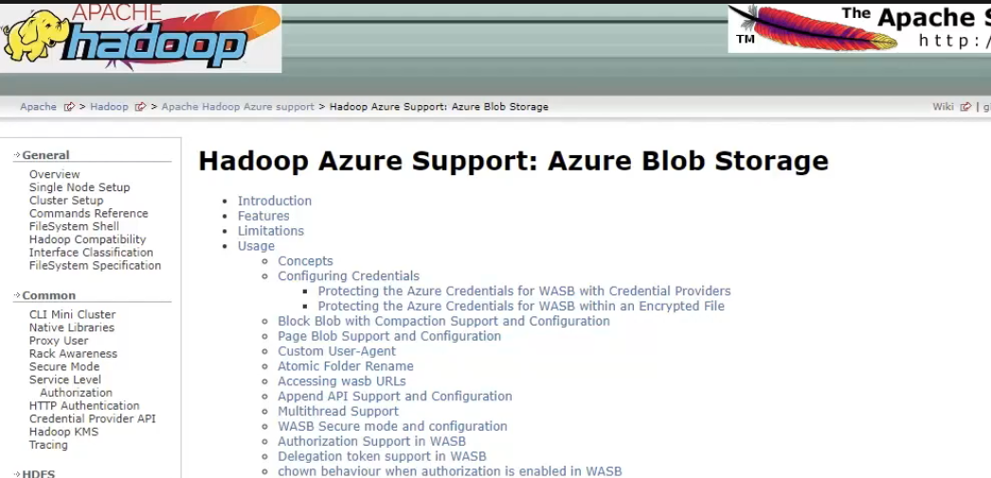

You can find it in http://hadoop. apache. org/docs/current/hadoop-azure/index. html. At a high level, a full ABFS URI looks like this.

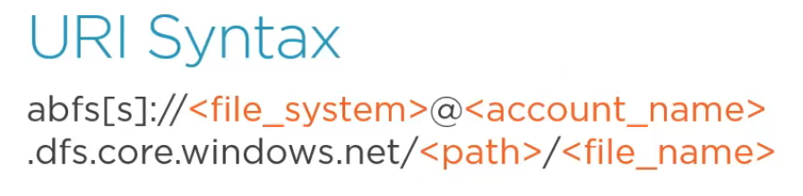

First, abfs, but it could have an extra s, which is used to connect with secure socket player connection. Then, the filesystem, which is the parent location that holds the files and folders. This is the same as a container in Azure Storage Blob Service, but you already knew that, as we have used it several times before. Then the account name, which is the name we gave during account creation, and it includes the full DNS, the path, and finally, the file_name.

In our case, using as an example some of the data we imported, it would look like this, abfs://datalakegen2hdifs@datalakesaps. dfs. core. windows. net/data/posts. csv.

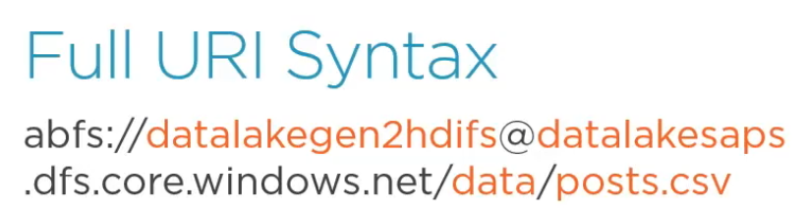

But this is the full URI. If the filesystem that you have set up is configured as a default filesystem, then this will work as well.

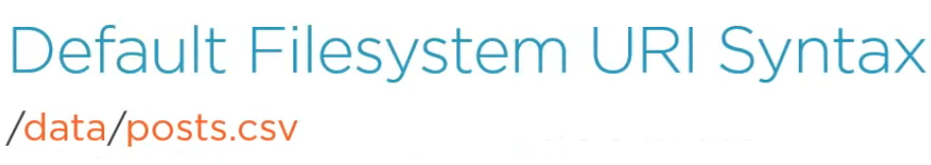

You should only include the path and the file name.

Now that we know about the ABFS driver, it is finally time for the demo. Let me start by opening my storage account, datalakesaps. And here I'll select Blobs. At this point, I have a new blob container that I created and I uploaded a few files and folders. I did it by using the Data Explorer. And this is the data that I want to copy. I can change to the terminal from one of the nodes that I have in my HDInsight cluster. And I can see these files using hdfs dfs -ls.

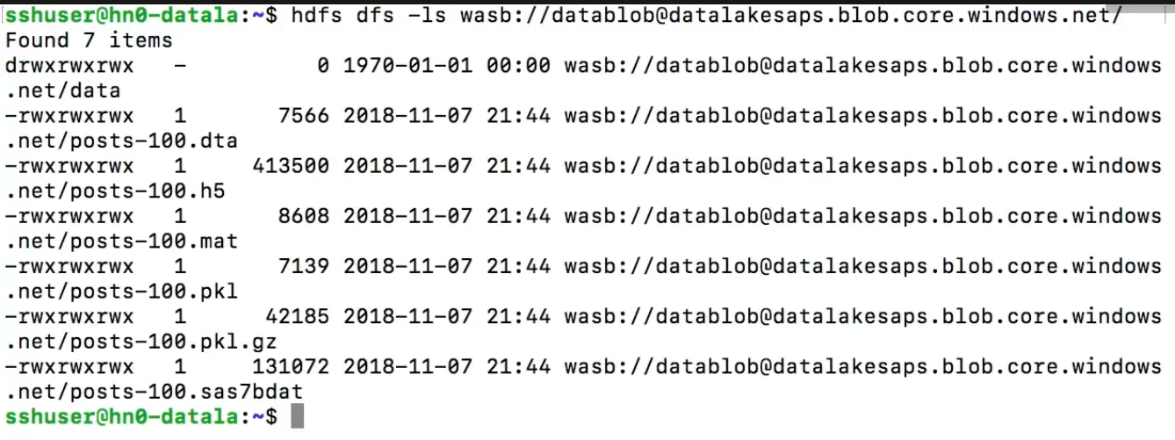

But as you can see, I am using the Windows Azure Storage driver, or WASB. Please note the full URI, including my container. And now I'm going to use the ABFS driver and create a new folder in my Data Lake Storage Gen2 to move these files. Creating a folder is easy. Hdfs dfs -mkdir -p and then abfs, the filesystem, which is datalakegen2hdifs, at the storage account, which is datalakesaps. dfs. core. windows. net and the name of the folder, which is datafromblob. Now I check using ls and I can see my folder right there, next to the other folders that I created earlier.

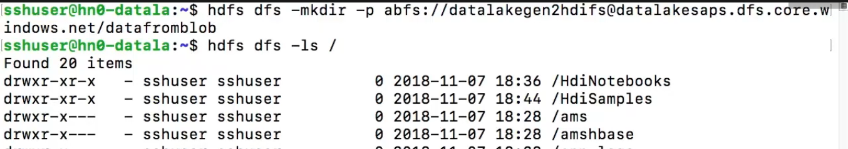

And now this is the command that we're going to run, hadoop distcp, and the source, which is going to be our blob container, so we use wasb://datablob@datalakesaps. blob. core. windows. net/posts*. I use the star so that everything is copied. And then the destination, which is abfs://datalakegen2hdfis@datalakesaps. dfs. core. windows. net/datafromblob. That's my destination.



And the MapReduce job starts. It takes a few moments to execute, but once it is ready, it provides a summary of what has been copied. And confirming is easy, I can use hdfs dfs -ls, and notice that since this node belongs to a cluster that has the file system as a default file system. I can use the shorthand syntax /datafromblob.

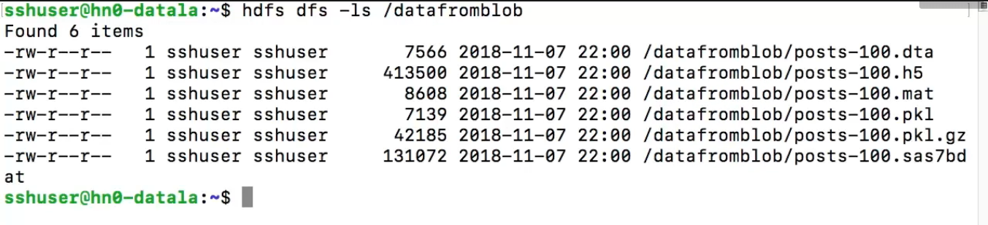

And our files are right there, which means that distcp with the abfs driver worked like a charm.

Copying or Moving Data to Azure Data Lake Store Gen2 with AzCopy

And now it's time to learn how to move data into Azure Data Lake Store Gen2 in yet another way, with AzCopy. AzCopy is a command line utility that's assigned to copy data to and from Microsoft Azure Blob file and table storage, using simple commands designed for optimal performance. AzCopy works in Windows, Linux, and Mac.   
And just a note, the version that works with Data Lake Storage Gen2 is version 10 and up. So please check the version to make sure you're using one that supports ADLS Gen2. Having said that, let's begin. I am here in my local Windows machine, and I run tree /f, I can see the folder structure with a bunch of files that I want to copy to Data Lake Store Gen2.

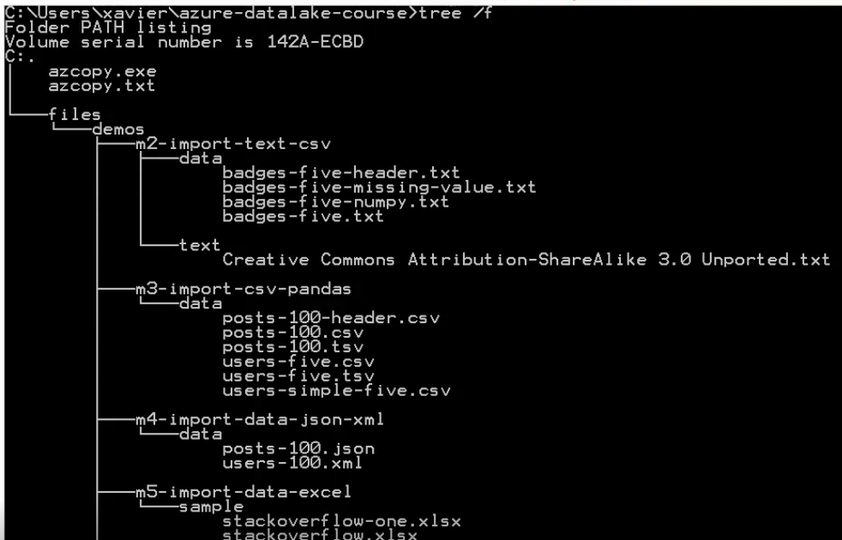

I have all kinds of data, from csv, tsv, json, xml, Excel files, MATLAB pkl files, and even a few databases. And so, let's upload this data. To use AzCopy we need two variables that I need to set. First the storage ACCOUNT_NAME, which is datalakesaps, and then the ACCOUNT_KEY. I'm pretty sure that by now you know where to get these values because we've been using them all along.



So now the command that we're going to use is azcopy, that's the executable, then the action, which is cp. For source I will use files/*, so it copies everything, and then my Data Lake Store Gen2. Please notice the scheme identifier, which is https, then ://, our storage account, datalakesaps, the DNS, the file system, which is datalakegen2hdifs, and then the path, which is datafromazcopy. And finally, I'll specify recursive true, so that everything is copied. At this point, copying starts. How long it takes depends on many factors, like the size of your data and your connection, but once it's done I get the statistics. And it's complete, so let's go and confirm.

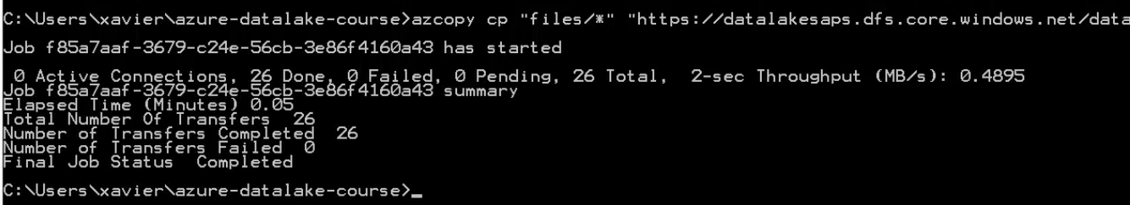

So of course, my preferred way is, old habits die hard, to use a Hadoop command, hdfs dfs -ls /datafromazcopy. And here we can see the folder, subfolders, and so on and so forth. And that is how you copy data using AzCopy. Quite simple I might say.



Takeaway

And now for the takeaway. In this module we learned how once you have created your Data Lake Store Gen2, the next step is to ingest data, for which there are many different ways of doing it. Today I showed you a few, which included distcp, or distributed copy, which is a tool that's commonly used in the Hadoop world to copy large amounts of data in parallel. Then we used Azure Data Factory, which is an Azure service that lets us move data to and from multiple data sources, which include, of course, ADLS Gen2. Then we used AzCopy, which is an application that can move data to and from Azure Storage, as well as local files, which is what were used today to upload some files to ADLS Gen2.

Additionally, we learned how to make calls to the REST API, which lets us make both file system and path calls to perform all kinds of operations. And all demos we covered the security aspect, remember not to take security for granted because if you do, you might end up in a lot of trouble. And something that was quite nice was to see how we could run the Hadoop commands that we're used to, like hdfs dfs, which worked transparently because of the ABFS driver, which takes me to my next point, if the Hadoop commands work seamlessly, that should mean that I can run big data applications against ADLS Gen2 without too much, right? And all thanks to the ABFS driver. Well, please join me in the next mod.

Using a Data Lake Store as External Repository with a Hadoop Cluster

Using a Data Lake Store as External Repository with a Hadoop Cluster. In the previous module, we learned how to create an Azure Data Lake Store Gen2 using a couple of different ways, which included PowerShell and Portal. Then, we dedicated another full module to learning how to ingest data into our data lake in a few different ways, which included Azure Data Factory, distcp, and AzCopy, as well as learning how to make calls to the Azure REST API, which is very useful, if you ask me. And now, in this module, I will demonstrate how to use Azure Data Lake Store Gen2 as an external repository for Hadoop clusters to execute big data jobs using one of the available platforms, like Apache Spark. Let me show you.

Data Lakes and Transient Clusters

First of all, let me tell you one very important reason of why data lakes can give a competitive advantage over other storage mechanisms, and let's use an old friend as an example. Many years ago, a new technology revolutionized the world by taking parallel computing to the masses. Yes, of course I am talking about Hadoop. And one of the main components of Hadoop was HDFS, or the Hadoop Distributed File System, which provided a way to store massive amounts of data in a resilient way and cost effective. As well as the many advantages that it had, it posed a few drawbacks.

* One that was quite notable was that HDFS was part of each cluster, and so if you de-provisioned your cluster, for whatever reason that you can think of, your data was gone, which meant that you usually kept your machines running in your data center, so you can imagine the costs.
* And also, for the resiliency part, data was copied three times, again, there's a particular cost right there.

But with Microsoft Azure and the cloud, one of the main advantages is that you provision and de-provision machines as required. You may have zero machines running and all of the sudden you have the need to process some data, so you spin up a few machines and instead of using HDFS as a repository, you use a data lake. So here's your data, which is now stored in your data lake, and once you're done, when you no longer need the compute power, you simply turn off the machines and your data is stored safely in your data lake. And next time that you need to process some data, you can spin up a new cluster, which connects to the data lake and performs any operations with the data. Brilliant, isn't it? But it goes beyond the specific and straightforward scenario. There are many more scenarios that are clearly defined in the cloud, which include the modern data warehouse, real-time analytics, and advanced analytics to name a few. All of which have a very notable common component, I mean they may have different sources, which may include logs, unstructured media, files, IoT sensors, and more. And then the data, which may go through different phases, which include ingest, explore, prep and train, model and serve, to finally being consumed by databases, applications, and analytic engines. But at the end of the day, what counts is that they all use a data lake, an Azure Data Lake Storage Gen2. Having said that, let me show you a demo.

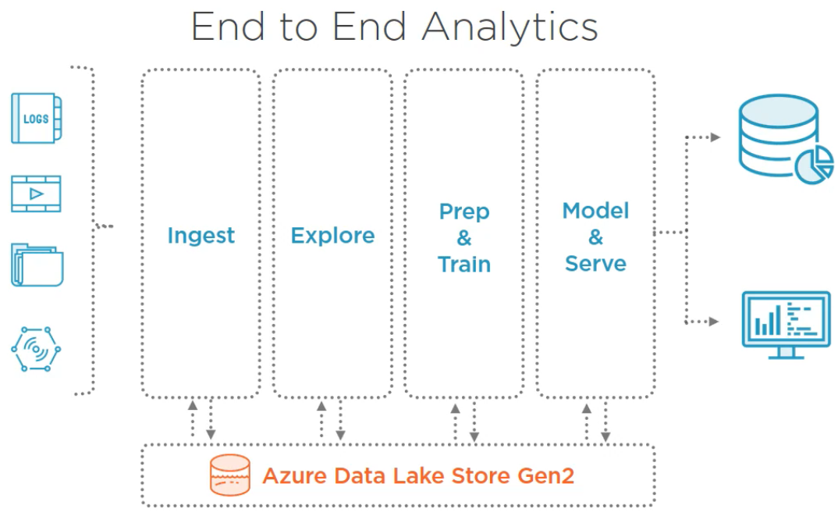

Demo: Setting up HDInsight Clusters with ADLS Gen2

Demo, setting up a Data Lake Store Gen2 Capable HDInsight Cluster. In previous modules, we created a data lake and then we ingested some data in a few different ways. And one thing that I did was that I used a terminal to run commands, like hdfs dfs -ls, and so on and so forth. However, at that time I had not shown you how to create a cluster that was able to work with Azure Data Lake Store Gen2 as file system, and the reason was that I didn't want to divert from my original objective, ingesting data. But now is a good time. And for this, let's go to Portal, then we're going to select Create a resource, then Analytics, and HDInsight. And now let's follow these steps, which are pretty straightforward.

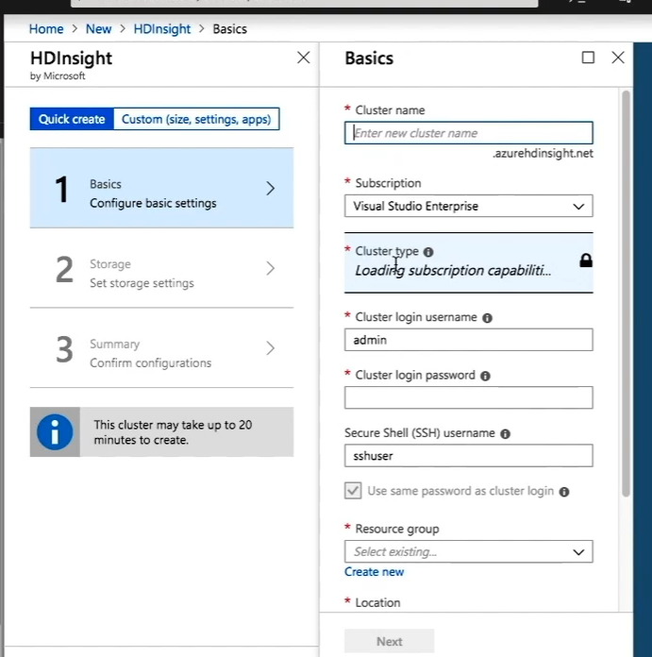

I will, however, emphasize which settings you need to be mindful of. First, Cluster name, pick one. I will use datalakegen2hdi. I will leave my subscription as is, then for Cluster type I will select Spark,

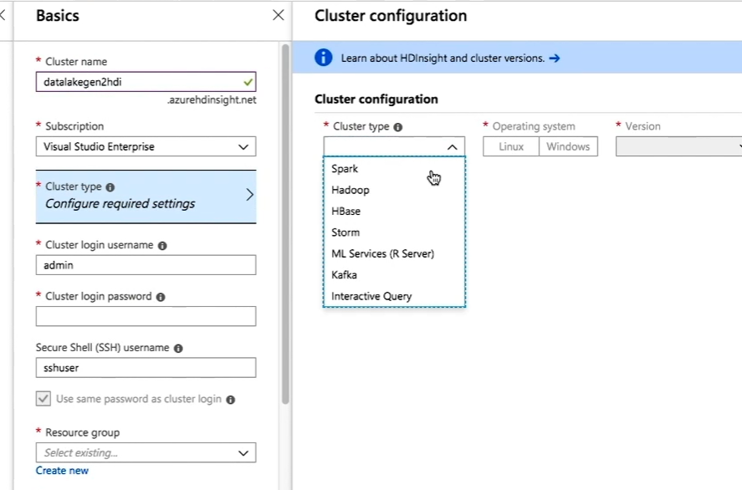

and this version 3. 6 works well. If you want, you can also pick 4. 0. Okay, so now let's click on Select. Now that we have that, the next step is to provide the password for the admin user, which is going to be the same password for the SSH user. Great, that is done. So now resource group, and for this one I will pick the one where we created the data lake, which is datalake-ps. And of course, we're going to use the same location, West US 2. There's also an option to view the course usage, but we'll see that also in the summary screen. So click on Next.

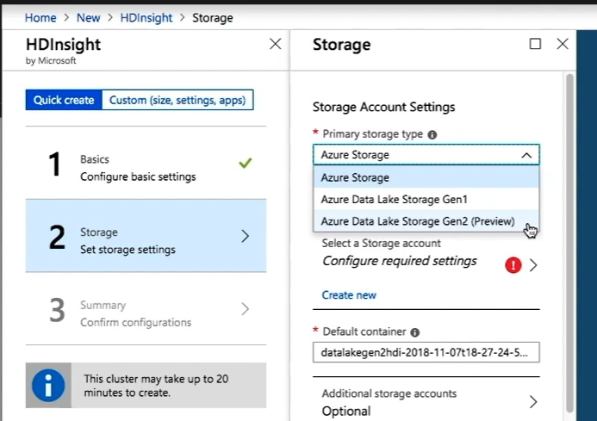

And now Storage, and this is quite important, for primary storage type select Azure Data Lake Storage Gen2. This is one of the most important settings when configuring your cluster, as this is where you set it to Gen2. Okay, good. Now that we have set that for subscription, I will leave as is. Use My subscription. Next, I'm going to select the storage account. I will pick the one that I created earlier where I already ingested a bunch of data, datalakesaps. Next, the default filesystem, this is the name of the container that will be created in this particular storage account, which will be the main filesystem for this cluster. To put it in simpler terms, this is going to be where all of our data for this cluster will be stored. I'll call it datalakegen2hdifs. Also, you can specify additional storage accounts, but I will leave as is for now. And this one may be important if you wanted to store your metadata outside of your cluster, here's where you set where. For this purpose, you can use an external SQL database.

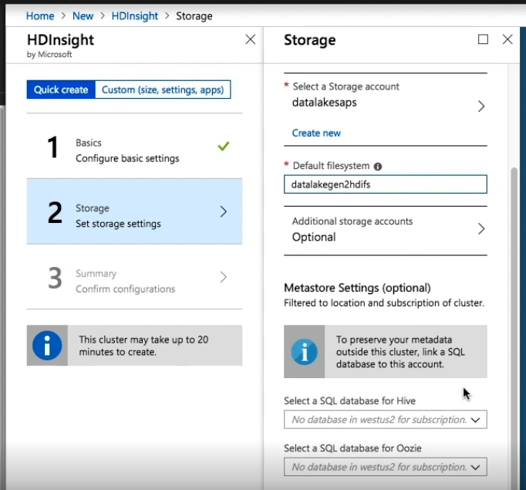

I won't, so I'll leave empty and click on Next. Now the Cluster summary, where a quick validation takes place. Here, I can review my settings and all looks good. At the bottom, you get an estimate of the hourly cost. Now click on Create and the deployment is submitted. You wait a little bit and the deployment is in progress. At this point, I'm going to open the Notifications and go to the Deployment page where, after a while, and I'll speed this up, I will see that my deployment is complete. I will go now to all resources and I can see my cluster right there. In here there are a few links that if you open, you can get all kinds of useful information and tools.

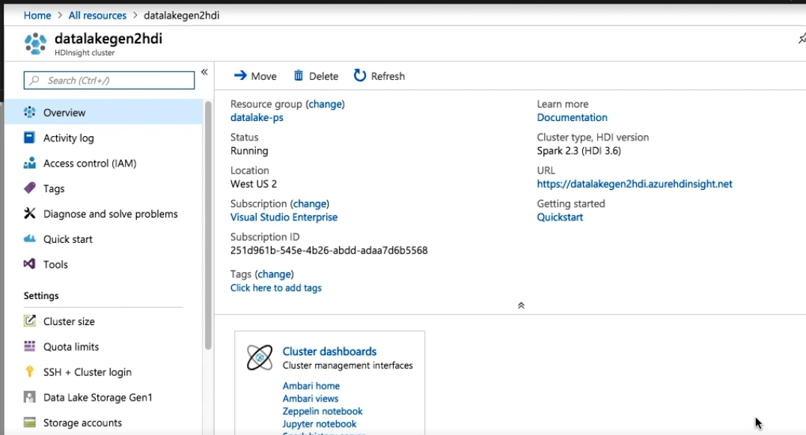

However, since this is not an HDInsight training, I won't get into the specifics, but at a high level, you can see, and let me quickly show you, the dashboard, Ambari Home, Zeppelin Notebook, Jupyter Notebook, Spark History Server, and Yarn. As a note, you will need to log in with your admin user with the password that you set on cluster creation. And now, back to Portal, where I can navigate to SSH plus Cluster login. Here I'll get instructions to connect, and it's easy. I just select the hostname and the SSH command is shown.

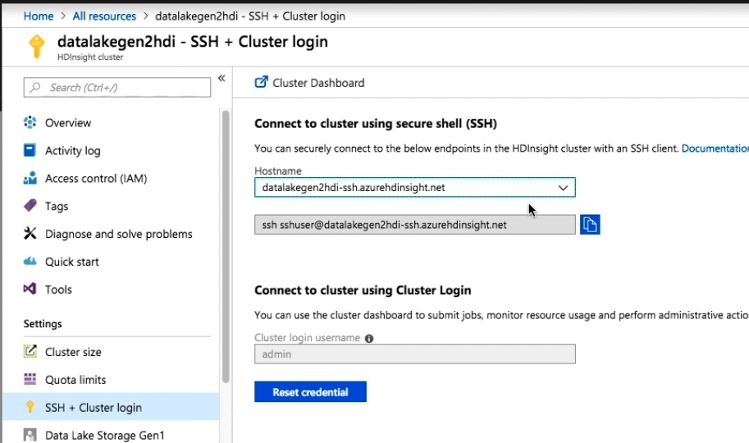

I will click on Copy and from any terminal that has SSH installed, just execute this command, ssh sshuser@datalakegen2hdi-ssh. azurehdinsight. net. And just like that, you have connected. Let's see, and I get the greeting, Welcome to Spark on HDInsight. Which means that now I can run Hadoop commands, like hdfs dfs -ls /, and I am connecting to Azure Data Lake Store Gen2, which is something that I already mentioned, but this is important to remember, my file system is a container within a storage account. And now it is time to run some Spark jobs on top of ADLS Gen2.

Running Spark Jobs with Data in ADLS Gen2 and the ABFS driver

Demo, running Spark jobs with data stored in ADLS Gen2. In a previous module, we uploaded several folders with data. There was one folder in particular called PostsCSV that we're going to use now as data to run a Spark job. If you want to follow along, please make sure that this folder is in the data lake, but if not, you can use AzCopy, Azure Data Factory, dist copy, or the REST API to upload it. I am pretty sure you know quite well by now how to ingest data into Gen2.

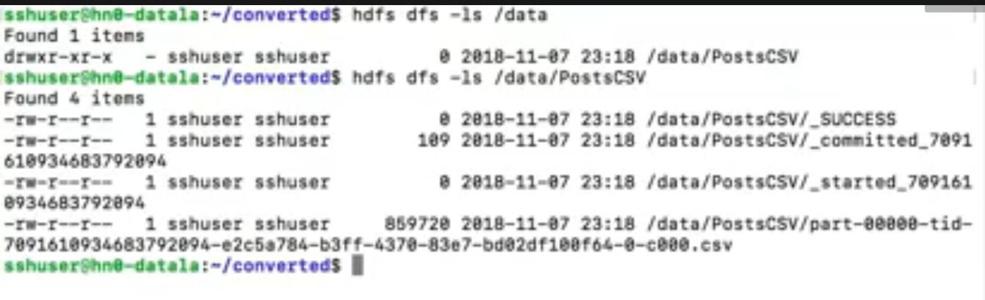

Having said that, let me show you how we execute Spark jobs, reading data stored in Azure Data Lake Store Gen2, which we can do in a couple of ways. First, we could use the spark-shell, and here we can execute one statement at a time. Or we could use spark submit to run our job, and this is quite easy to do if you know Spark, but since you have a cluster up and running, why don't we try something different. Let's go back to Portal and open the Jupyter Notebook, which is a web application that we can use to execute code, including Spark. We can select our language of choice, PySpark means Python 2, PySpark3 is Python 3, and Spark means that you use Scala. Now let's give it a few seconds for the kernel to start, and now it is ready. But since this is not a Spark class, I won't get too much into the details of Spark programming, but if you're interested, I have two courses that cover developing Spark Applications at length using either Python or Scala. So whichever is your language of choice, I've got you covered. And this is quite straightforward, it goes like this, import pyspark, then I need to create the session and I run this cell. And here's the juicy part, posts_df = spark. read. option, I specify that my file has headers, then. csv, and I specify the path. Please notice that I'm using the ABFS driver and the path is abfs://datalakegen2hdifs, that's the file system, @datalakesaps, that's my storage account, then the DNS,. dfs. core. windows. net/data, this is my final path to the folder, /PostsCSV. What's really nice is that for Spark, this is quite transparent. If the data was stored locally or in HDFS, the path would have changed, but the statements are the same. So now that I have my data frame, I can select and show. This worked like a charm. And that, ladies and gentlemen, is how you connect to a Data Lake Store Gen2 from an HDInsight cluster to run a Spark job. Easy, right? And the answer is yes.

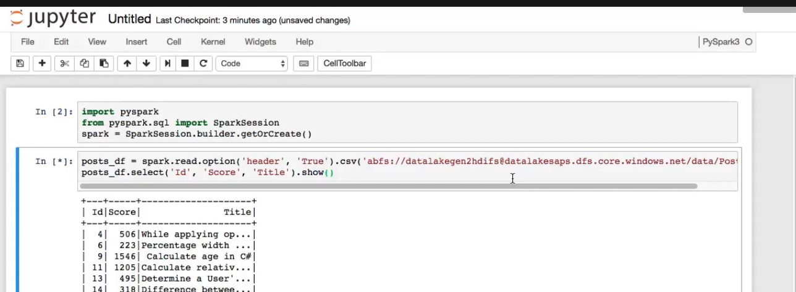

So now it's time for the takeaway.

Takeaway

Takeaway, Hadoop changed the world by democratizing big data, and most likely it would not have been able to do it without the Hadoop Distributed File System, or HDFS, which provided a cheap and resilient way of storing and working with data. But there was a detail, HDFS was part of the cluster itself, so a deprovisioned cluster meant no more HDFS service, which means no data. But that is not the case if you use an external repository, which works great for transient clusters. And this is where Azure Data Lake Store comes into play. Azure provides an HDFS based data lake, originally with Gen1. But then Azure provided a better alternative, one that has a hierarchical object store that's HDFS compliant and based on Blob Storage instead, what we know as Gen2. Which meant that you can spin up clusters as needed to run your big data jobs with Spark or with Hive, Impala, or other big data platforms. And then you can deprovision your cluster when no longer needed, with the advantage that you would not lose your data. And you could even store your metadata, like in the case of Hive, outside of your cluster. And there are several well defined patterns that you can use to leverage and take advantage of Azure Data Lake Store Gen2 for end to end analytics, which include the modern data warehouse, real-time analytics, and advanced analytics. Having said that, it's time now for the final takeaway.

Wrapping Up

Final Takeaway

Final takeaway. We are living in a very interesting time in human history, never before has data been so readily available in such large quantities and with so much computing power. No wonder why some people say that data is the new oil. And for storing such vast quantities of data, we use large data repositories that are known as data lakes. And when working with Microsoft Azure, you use Azure Data Lake Storage Gen2, a large object store that's HDFS compliant but built on top of Blob Storage, which gives you the best of both worlds, including a hierarchical namespace, allowing you to store your data at massive scale with great performance at a low cost and integrated with the major Hadoop vendors.

And once we covered the higher level details of Gen2, we learned how to create a Data Lake Store Gen2, it was quite easy. We also learned how to ingest data in a few different ways, which include distcp, or distributed copy, a tool that's very familiar for long time Hadoop users, as well as Azure Data Factory, which is a service that lets you read from many different data sources and create pipelines where you can copy over your data into Gen2. We also used AzCopy, a command line utility that's quite familiar to those that have been moving data in Azure Storage.

Next, we learned how to work with the REST API, which lets you perform many actions, both file system and path, and once you have ingested your data, it was time to work with it, which as we saw when we worked with Hadoop commands, like hdfs dfs, it was no different. Same thing when we ran a Spark job, we only needed to modify the URI, and I did not show you, but if I would have used Impala or Hive, the process would be no different. And all this thanks to the new ABFS driver. ABFS stands for Azure Blob File System driver. It made our work quite easy. And I demoed using a Hadoop cluster that I built using HDInsight version 3. 6 and above, which works quite nicely.

And going beyond, Gen2 is currently supported, or will be rather soon supported, by other vendors, for example, Cloudera.

And finally, remember to always take security seriously. Security comes first. Your data is a precious asset that gives you a competitive advantage and Azure gives you many ways to secure your data. So make sure that your data is safe. Which means that you can spin up clusters as needed to run your big data jobs with Spark, Hive, Impala or other big data platforms and deprovision your cluster when no longer needed, and you will not lose your data. You could even store your metadata, like in the case of Hive, outside of your cluster. And having said that, I want to thank you for taking the time to watch this course, Implementing Microsoft Azure Data Lake Storage Gen2. I am Xavier Morera, and feel free to ping me on Twitter, ask questions in the discussion below, or contact me through my site.